- Salsa O’Keefe – We’ve always loved Latin music - so strange that it took us until now to really have a blow at it. No matter, this is a Bronx story and dedicated to a major influence, Bert Berns, songwriter and producer extraordinaire! How about Mr. Hamlin’s cowbell!

- Culchie Prince – A memory of a wild weekend in the County Clare shortly before I first left for New York. A “culchie” is anyone unsophisticated enough to be born outside the city of Dublin; while a “brasser” – in my day - was a young working class Dublin lady, unafraid to speak her mind who invariably sported peroxide curls. And oh, those crazy uilleann pipes, Joseph Mulvanerty, blowing like a gale from the Bronx to the Cliffs of Moher.

- Dublin Days – Everyone I knew lived close to the borderline in Dublin and yet we always found ways to cadge a pint and fall in love. Even today, if I walk from Stephen’s Green to Trinity College I invariably brush against her shadow. This is for every college student who ever spent a semester in Ireland. Go Christine, the Beehive Queen!

- US of A 2014 – It amazes me how people can be so resistant to fixing a system that will consign their children to second-class citizenship. Profits rise, wages fall, Connolly turns in his grave, and Black 47 is outa here! But the question remains: Who stole the scent from the American rose?

- The Night The Showbands Died – Fran O’Toole had a voice to die for. There wasn’t a culchie rocker who didn’t adore him. My teenage group opened for The Miami Showband a couple of times; we were awful, Fran couldn’t have been nicer. I had moved to the Lower East Side in 1975 when news of the massacre broke. It seemed unreal, it still does. Fred’s subtle trombone chorale is a tribute unto itself to the great horn players of the showband days.

"Silicon suits, ballroom romance
Belfast on fire, would you care to dance?
All mixed up, no rhyme nor reason
Don’t cross the Border in the middle of Marching Season…”
Songs have a way of shooting you back in time, don’t they? I only have to play the first chords of The Night The Showbands Died and I’m right back in Ireland in the summer of 1975.
It was a bad time. Sectarian killings had become the norm up North; but being relatively early in the conflict, there was still an inkling of hope that things could get better.
Thin Lizzy, Rory Gallagher and Planxty ruled the cool scene, while showbands dominated dancehalls on both sides of the Border. A band had to know two national anthems and be ready to play whichever depending on the community. In the rare “mixed halls,” the lights came up instantly after the last song to forestall any provocative requests for either A Soldier’s Song or God Save The Queen.
In reality, though, showbands were hurting. Punters no longer wished to attend alcohol-free parochial dances. Large pub lounges featured three or four piece groups while strobe-lit discos were now more to the taste of the dancing populace.
The Miami Showband was an exception. An institution since the early 60’s this Dublin outfit was surging again in popularity largely because of lead singer, Fran O’Toole. An unlikely mixture of Otis Redding and Georgie Fame, Fran wasn’t a great showman – no it was that voice; it would stop you dead in your tracks at a dance and you’d find yourself standing alone humming along while your friends danced off with the pretty girls.
Fran was a beautiful guy. My band opened for the Miami a couple of times in Wexford; we weren’t just bad, even our friends considered us god-awful. Still, Fran always made a point of commenting favorably on some song that we’d totally butchered. Later on in Dublin if I ran into him at the Television Club on Monday’s Showband Night Out, he’d favor me with a friendly wink.
I often wondered what was the vibe like at the Miami’s last gig in the Castle Ballroom in Banbridge, County Down. As ever the six piece signed autographs and chatted with the punters before setting out on their fateful return trip to Dublin.
Another band heading home
Down the AI to Newry Town
"British roadblock up ahead”
They had reached Bushkill, seven miles north of Newry, when they were flagged down by a group of men dressed in British Army uniforms. Though in disguise, four of these were actually members of the Ulster Defence Regiment (UDR) a British Army regiment; all were members of the dreaded Catholic-hating, Ulster Volunteer Force (UVF).
"Good night lads, what’s the craic
Step out of the van, it’s just a wee check.”
Lined up by the side of the road, the band was not unduly worried, for a British officer had arrived and seemed to be in command. Then bassist, Steve Travers, heard the “soldiers” rummaging in the back of the Volkswagen van and was fearful for his new guitar.
"Careful with that guitar there, man
What are you putting in the back of the van?”
They roughly shoved Steve back in line, luckily for him, for the soldering came loose on the bomb they were planting and it detonated, ripping them to shreds. The remaining “soldiers” opened fire killing three of the band and badly injuring two others. They chased Fran through a field and pumped 22 bullets into his face.
Awful things had already happened up North, but all innocence evaporated that night. Bands refused to cross the Border and contact between the communities froze.
It’s almost 40 years ago but the case will soon be reopened, for some of the survivors and families of the deceased have sued the British Ministry of Defence and the Chief Constable of the PSNI over suspicion of collusion between the British Army and the Loyalist gang.
We’ll never hear Fran O’Toole’s amazing live voice again, but perhaps someday we will get the full story of the night the showbands died.

- Johnny Comes a’Courtin - Did the Irish invent Reggae? You can hear the lilt of the melodies and the dropped “th’s” all across Marley’s magnificent music. Oliver Cromwell sent his Irish prisoners to the Caribbean islands. They intermarried with the African slaves and formed a new culture. Ms. Oona Roche summonses the spirit of a young 17th Century Irishwoman who has a momentous decision to make.

- Let The People In – There’s always been a No Nothing Party that wishes to pull the ladder up behind its adherents. But immigration is the lifeblood of this country and its economic engine. Then again, I lived here illegally for three years, so I’m probably biased. Play that funky bass, Mr. Bearclaw!

- Lament for John Kuhlman – He was Fred Parcells’ roommate and collaborator. A sax-playing composer with an open heart and a smile for everyone, John was a big unfocused talent. He had demons – who hasn’t? - but that last night we partied with him in LA, it seemed like he had them under control. That’s his music-box opening the track.

- St. Patrick’s Day – I’ve always seen March 17th as a wild stallion. Once you’re atop its back, you’ve no choice but to hang on and hope for the best. Puritans may want to regulate and control it but, in essence, it’s the Irish stating that they have survived, they have arrived, and to hell with inhibition!

- Queen of Coney Island – I still love it out there on the boardwalk but it used to be a pulsing paradise. The music, the lights, the Atlantic, the ladies of the night, innocent and otherwise, I drank it all in through small town eyes like an icy beer on a sweltering day. Shotsie, Legsy, Mr. Ragonese, and Hot Lips, where are you now?

- Shanty Irish Baby – It’s pretty much vanished, the split between Lace Curtain and Shanty. But late at night in the back rooms of old-man saloons you can hear its echo, and I always know which side I’m on. What a soprano solo from Mr. Blythe!

- Ballad of Brendan Behan – We loved him because the straights all hated him – he was a “disgrace to the Irish.” But to us he was a big man in a small country. Was he the first modern victim of fame, or just another drinker with a writing problem? Whatever! He was our Borstal boy and rebel without pause.

the ballad of brendan behan
Born in the glory of Russell Street
You grew up humming Amhrán na Bhfiann
Your auld lad did time in a Free State jail
For Republican activities beyond the pale
You were your Granny’s best boy, your Mammy’s best chap
You loved to butter the old ladies up
But your soul had been scorched with the orange, white and green
You were the one and only Brendan Behan
I often wonder about biographies. Can you really get to the truth of someone you’ve never met?
I was an avid reader of biographies until I happened on one about a friend, Lester Bangs, the iconic rock critic. It was well written and researched, and captured the public image of the man to a T but had scarce little to do with the troubled, insecure person that I often encountered late at night in the Bells of Hell.
Turned out the writer had only met Lester once, and obviously on an occasion when Mr. Bangs was in top myth-making form.
I was very aware of this when writing The Ballad of Brendan Behan for Last Call, the final Black 47 CD. What was the man really like, and when exactly did he morph from the dynamic, socially conscious writer to the pugnacious, often-inebriated public figure of his later years?
One thing for sure, Brendan Behan packed a lot of living into a short life before succumbing from drinking and diabetes 50 years ago. Even back then, few had seen his plays or read his books and yet he was the most infamous Irishmen of his time.
Did the fame kill him or was he always on a one-way track to destruction? One thing I do know, you have to shovel aside a lot of media exaggeration and infatuation to get to the heart of the man. That being done, you come face to face with a force of nature and a very original voice.
For Brendan Behan was the proud, unfettered spokesman for working class Dublin. True, Sean O’Casey had already paraded vital inner-city characters across the world’s stages; but the abstemious O’Casey wrote about other people, Behan rarely wrote about anyone but himself. And therein, lay the seeds of his downfall. For you need a cool head and a pragmatic disposition to navigate the reefs that separate the private from the public personae.
Brendan possessed neither. He was all passion and heat, with no little interest in self-promotion and celebrity. It’s interesting to contrast him with his spiritual heir, Shane McGowan, another singular voice of the people.
Shane has never hidden Behan’s influence, and why should he? He’s one of the many who benefited from Brendan’s proletarian trailblazing. And yet the gap-toothed London singer from day one has had a healthy disregard for the media. Perhaps, that’s what has kept him alive.
“Critics are like eunuchs in a harem; they know how it's done, they've seen it done every day, but they're unable to do it themselves.”
Despite the defiance of this quote, Brendan – unlike Shane - was deeply wounded by criticism, especially in his final years when it became obvious that he had wasted his talent in endless pub-crawls.
But could his fate have been any different given that he spent so much of his youth in prison, sometimes in solitary confinement? Undoubtedly an alcoholic, he rarely drank at home but was always in need of the warmth of a pub, the liberating effect of gargle, and an audience.
Without fame and publishing advances he would have been just another garrulous drunk who would eventually stagger home and deal with the hangovers and empty pockets. Instead there was always someone who wanted to bask in his glory or a press photographer with an eye for a juicy story.
In the end though Brendan opened the door for so many who didn’t have the proper accent, background or education, but like him had the burning desire to tell the unalloyed story of their lives. And that’s why the “laughing boy” still matters 50 years after his death at the age of 41.

You left us your poetry, your soul and your dreams
You’ll always be our one and only Brendan Behan
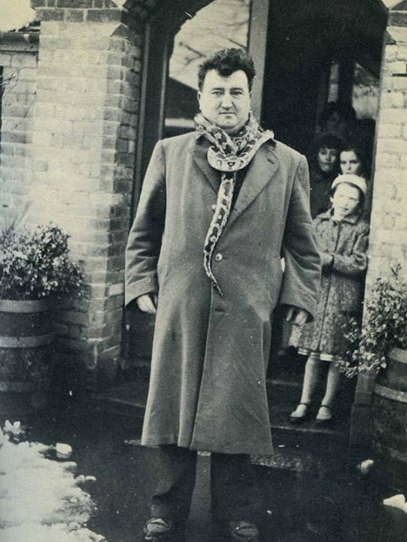

- Hard Times – I never cared for the teary-eyed versions of this song – they just miss the point. Foster was far from the melancholic innocent. Guy survived the Five Points for over three years when it was the most notorious slum in the world. He could have quit and gone home. But he was too proud. Was he searching for something or just couldn’t admit defeat? A fitting song for Black 47 to go out on.

